President’s Message March 19th, 2021
Happy February!
It is just so exciting when the days get longer and when I go to work and come home at night, it is still light. This time of year, always gives me hope that winter is powering down and spring is powering up. I have ordered plants for my pandemic garden already!
I just want to say how much I appreciate the people I work for. You are a fantastic group of teachers who care deeply for their students and colleagues. That makes my job a whole lot easier. There have been days during this year when I have felt more worn out than I do during a strike year. I know you have too! Thank you for putting in all the effort to keep yourselves, your colleagues and your students as safe as we can. The extra effort in planning, cleaning, redoing the plans, cleaning again, etc. haven’t gone unnoticed.
There are quite a few services available for you during through this office, the BCTF and the EFAP program. Please take advantage of those services. You pay for them through your dues. Those services include but are not limited to: Psychologist, counsellors, Living with Balance course for teachers only, Health & Wellness program, Mentoring program, Collaboration program, etc. Call me if you need help accessing any of those services.
Sylvie de Grandpre and Deleen Adams have developed a fantastic CDTA Collaboration Project. Sylvie presented it to the Executive last week. The premise is that teachers interested in collaboration will blitz a school who has requested the service and work with the teachers as a whole, both in and outside the classroom. I am really excited to see how this works. TTOCs will be provided through the week to release classroom teachers to collaborate. Sylvie & Deleen hope to have this project up and running in the first week after Spring Break. If you or your school is interested, please contact either teacher at their SD5 email addresses. Let’s do something fun and interesting in the last quarter of the year. Enough of the doom and gloom of the pandemic right now!
Masks & our students – As much as I appreciate Bonnie Henry and her quiet demeanor, I am a wee bit frustrated by the latest news on the protocol. There are so many ambiguous statements and unanswered questions! The COVID19 committee is reviewing the documents over the weekend and we will meet on Tuesday to revise SD5’s protocol. I know that you have received the information to update the mask protocol already.
Finally, if you have any parents wondering about the FSA and worried about the hassle, please have them contact me at the office. I’ll give them the courage to stand up to the man! Shelley

Vice-President’s message
Spring has sprung and our brains are done!
6 out of 10 months down, 4 to go! And oh boy, are the remaining months ever going to go fast!
The February cold snap almost broke my will, and despite many grumbles and mumbles, I made it through, and the longer days and warmer temperatures are giving me hope.
Since the summer months I have been listening to a lot of podcasts. Personal favorites are Brene Brown, Tim Ferriss, and Sam Harris. I honestly pick up about one third of the content at any one time, and when I get a chance to re-listen, I always pick up more tidbits of knowledge and fun facts. In a recent Brene Brown podcast she discussed The Long and Winding Path to Healing. Now why would I need to listen to such a topic? I need to heal. Over the Spring Break, we all need to heal from the ongoing stress of teaching during a global pandemic.
A quote during the podcast that stuck with me was, “don’t be everything you think”. As teachers, we have to be a lot of things to a lot of people and then we have to be part of our families. Do I think I am tired? Darn tootin’! Do I think I can create a better lesson to get kids to understand paragraph organization? Probably… Do I think I can be more kind to my spouse? Very likely… but I can’t do everything all the time.
We teachers are (a bit) controlling of ourselves, the little people we teach, and (just sometimes) our family. We simply cannot be that person wearing all those hats at the same time – we cannot live and be everything we think we are without some cost to ourselves. I may not have my best lesson every day I teach, but that does not make me a bad teacher nor a bad person. Teachers are doing an extra-ordinary job under extra-ordinary circumstances in an extra-ordinary time – just be kind to yourself and don’t be everything you think.

Finding a balance with work, family, friends, and health during the school year is tough enough at the best of times. I know that I feel like a different person during the summer months than I do during the school year – it’s my recharge time. I must remind myself that I cannot be the summer person while I am a teacher. I don’t have the same stressors or time to take care of myself. I might incorporate healthy habits from the summer to keep me healthy during the school year – that is a start. As Spring Break rolls up, remind yourself that you cannot be the same person you were last year at this time or even years before “The COVID”. You can be kind to yourself and give yourself some fresh air therapy, laughter, mediation, reading, music, or whatever bit of life that keeps you healthy and happy. Make that kindness to yourself a habit. Don’t be everything you think.

I really hope you find a bit of peace in the 2021 version of Spring Break. We all need a bit of that – and even if we do not get it on a warm beach, in a foreign country, far away from the worries of home and work, I hope you get just a chance to choose some kindness and change.
Take care my friends and colleagues,
Connie

Winter Representative Assembly January 28-29, 2021
The Winter Representative Assembly focusses around organizing finances. Stability in our finances is important for our operations, pensions, and strike funds. For detailed notes, please log on to your BCTF portal, under Resources, Governing Body Documents, RA Minutes, January 29-30, 2021 Winter RA Minutes.
Please log into MyAccount which is a secure site and you can work with an agent who can browse with members in real time and help you with questions about your pension. Please log into your account, even if you are not near collecting you pension, to make sure that your contact information is up to date.
2020 funding levels show that pension funding returns are healthy (approx 2.8%) and there is a positive funding level. The Cost of Living Allowance is not guaranteed but reviewed every three years and the COLA for 2020 was 1.9% and for 2021 was adjusted to 0.5%.
RESOLUTIONS
Elections Canadian Teachers’ Federation Annual General Meeting Delegates: Farid Azar (Mission), Jessica Hill (Cariboo Chilcotin), Rick Joe (Chilliwack), Don Peterson (Saanich), Kelly Snow (Peace River North), and Winona Waldron (Greater Victoria). Alternates: Amandeep Grewal (Vancouver Secondary), and Elizabeth Rush (SEPF).
Executive Committee recommendations Cohort model: That the Federation advocate through all available avenues—including publicly—that unless revised to improve prevention, protection, consistency, and efficacy of implementation, that the cohort model not form part of any necessary safety planning for the 2021–22 school year, and be supplemented with a plan that includes improved guidelines regarding mask and barrier usage, physical distancing and reduced density, and ventilation, cleaning and disinfecting.
Donation—BC Federation of Labour: That a donation of $10,000 be made to the BC Federation of Labour for their collective legal action fund for the purposes of an application under the School Act to remove trustee Barry Neufeld, to be charged to the Contingency Fund.
Finance
2021–22 membership fees: That the Representative Assembly recommend to the Annual General Meeting: That for the 2021–22 membership year, the fee for those who are members under By-law 1.1(a) shall be 1.69% of the actual salary of the member, allocated as follows: 1.319% to the General Operating Fund 0.22% to the Collective Bargaining Defence Fund 0.074% to the Public Education Defence Fund 0.050% to the Provincial Bargaining Fund 0.027% to the W.R. Long International Solidarity Fund 0.000% to the Contingency Fund. Except that the fee for active members who are teachers teaching on call shall be 1.590%.
2021–22 minimum local fee: That the Representative Assembly recommend to the Annual General Meeting: That, effective July 1, 2021: That for the 2021–22 budget year, the minimum local fee for BCTF grant purposes be $475.
Donation—BC Federation of Labour: That the $5,000 donation that was made at the January 14–15, 2021, Executive Committee, to the BC Federation of Labour, for a collective legal action fund for the purposes of an application under the School Act to remove trustee Barry Neufeld, be charged to the Contingency Fund.
Fee for affiliate administrative membership: That the Representative Assembly recommend to the Annual General Meeting: That for the 2021–22 membership year, the fee for affiliate administrative membership under By-law 1.6, exclusive of the Salary Indemnity Plan, be $100.
Fee for affiliate membership: That the Representative Assembly recommend to the Annual General Meeting: That for the 2021–22 membership year, the fee for those who are members under By-law 1.6 (affiliate membership) shall be an amount negotiated between the BCTF and the affiliate, on a fee-for-service basis.
Fee for associate membership: That the Representative Assembly recommend to the Annual General Meeting: That for the 2021–22 membership year, the fee for those who are members under By-law 1.2 (associate membership), shall be $100, except that the fee for associate members who are uncertified teachers’ replacements shall be 1.690% of the actual salary of the member, and except that the fee for associate members who are students enrolled in programs of study in university/college programs leading to certification as teachers shall be $1.
Fee for member on leave of absence: That the Representative Assembly recommend to the Annual General Meeting: That for the 2021–22 membership year, a member who is on leave of absence either without pay or on deferred salary leave, remains an active member, without payment of fees.
Fee for member under By-law 1.1(b): That the Representative Assembly recommend to the Annual General Meeting: That for the 2021–22 membership year, the fee for active membership for those who are members under By-law 1.1(b) shall be the same as the fee for active members under By-law 1.1(a), provided that the Representative Assembly may, in establishing policy regarding the eligibility of such members, waive or modify the fees.
Procedure 10.L.12: That Procedure 10.L.12 be amended as follows: 1. Amount of pay: a. $50 $100 a day commencing on the first full day of a member’s involvement in a BCTF authorized strike; b. $50 $100 a day commencing on the first full day of a member’s involvement in a lockout; c. $50 $100 a day commencing on the first full day of a member’s involvement in a third party dispute; and, subject to (d) will continue for each work day the individual is not at work providing that they perform picket line duty or other job action support as determined by the local executive.
Fee for member on leave of absence: That the Representative Assembly recommend to the Annual General Meeting: That for the 2021–22 membership year, a member who is on leave of absence either without pay or on deferred salary leave, remains an active member, without payment of fees.
Fee for member under By-law 1.1(b): That the Representative Assembly recommend to the Annual General Meeting: That for the 2021–22 membership year, the fee for active membership for those who are members under By-law 1.1(b) shall be the same as the fee for active members under By-law 1.1(a), provided that the Representative Assembly may, in establishing policy regarding the eligibility of such members, waive or modify the fees.
Local resolutions
BCTF three-layer masks: That the BCTF immediately demand that the employer supply three-layer masks and distribute two-per member in regions with high positivity rates as soon as possible.
High-speed internet access: That the BCTF investigate the feasibility of ensuring access to high-speed internet, and other technological needs to all BCTF facilitators.

Local resolutions continued
Investigation of men in the profession: That the BCTF address the continuing decline in numbers of men in the teaching profession by quantifying the extent of the decline, identifying the potential impacts of the decline on public education and in the community at large, investigating the causes of the decline, and taking steps to redress the increase of gender disparity in the teaching profession with a report back to the Fall Representative Assembly.
Investigation of school psychologists: That the Federation investigate working conditions and recruitment and retention issues for school psychologists and the impacts these issues have on collective agreement provisions such as class size and composition.
Labour Relations Board complaint: That the BCTF file a complaint with the Labour Relations Board Trouble-shooter to address provincial COVID-19 guidelines and the inequities between mask mandates in private versus public schools.
Mobilization School Union Representative Training: That the BCTF Mobilization School Union Representative Training workshop be updated so that it is ready to be offered for the start of the 2021–22 school year.
Rapid testing: That the BCTF demand of the government that rapid testing be offered to the entire school community when a class is asked to self-isolate or when a case of one of the new variants is discovered in the school setting.
Reconciliation plans, policies, and training: That the BCTF encourage each local and sub-local to petition their school district to: 1. adopt the Truth and Reconciliation Commission (TRC) Calls to Action and to use the United Nations Declaration on the Rights of Indigenous Peoples (UNDRIP) as a guide when creating new strategic plans and policies. 2. provide meaningful training to all staff on an ongoing basis, including school district trustees, on the topic of reconciliation that would incorporate the challenging of thinking, structures, and systems that perpetuate colonialism.
Regional approach to COVID-19: That, due to the alarming rise in COVID-19 cases in schools province-wide, the BCTF Executive Committee demand that the government immediately change to a regional approach regarding class size and/or density with specific data informed benchmarks to move between approaches.
School associates/advisors’ workshop: That the BCTF create a workshop for school associates/advisors that focuses on anti-oppression, orientation, and assist locals to facilitate the participation of school associates/advisors in their locals.
Solidarity with Dr. Amie Wolf: That the BCTF Executive Committee make a statement of solidarity with Dr. Amie Wolf that asserts teachers’ commitment to the Truth and Reconciliation Commission (TRC) Calls for Action and to the United Nations Declaration on the Rights of Indigenous Peoples (UNDRIP) in response to the recent incident in the UBC teacher training program.
Subsidization of private schools: That the BCTF work with the Canadian Teachers’ Federation (CTF) to condemn government subsidization of private schools and to bring this issue to the forefront of a national discussion.
United Nations Declaration on the Rights of Indigenous Peoples: That the BCTF encourage locals to bring a motion to school boards that they adopt a commitment, and plan of action, to the United Nations Declaration on the Rights of Indigenous Peoples (UNDRIP) ensuring curriculum, infrastructure, and staffing decisions, include consideration of the impacts on Indigenous students and their families.

know your contract
Transfers – Any Transfer to a school must be sent to Brent and CC’d to the CDTA before March 331, 2021.
Transfer to another school E.14 – please be very specific if you want a particular grade or class – if you want a different school and don’t mind what grade, you can say that too.
Extended Leave Request G.27, G.30 – This is when you have Deferred Salary or just need an Unpaid Leave from teaching – again, please email Brent and CC the CDTA before March 31, 2021.
Maternity and Parental/Adoption Leave – G.12 – If you choose to extend your maternity leave, you may apply for an extended leave under G.12.1.a before May 31 or four weeks prior to the start of a semester or term.
If you are thinking or planning to take a leave, please let the CDTA office know sooner than later!

BCTF Annual General assembly - march 20 - 24, 2021
Like everything else, this year’s BCTF AGM is going to be held virtually! So instead of sitting in a room in some swanky Vancouver hotel ballroom, you can join in the conversation and business of the BCTF via the comfort of your own home or join Shelley and Connie at the CDTA office.
You will be given a $100 dividend to spend of meals or snacks for those days and learn a lot about how the BCTF works! Please let Shelley know if you are interested!

Let’s talk about Privilege
Privilege is invisible to those who have it. To create a context which embraces diversity, in which no one is marginalized, a conscious and ongoing effort is required. Noticing and changing what we take for granted, we make room for everyone’s contribution. Consider the following questions:

Do I tend to always speak first, interrupt of take more than my share of space?
Do I unilaterally set the agenda?
Do I assume I’m more capable?
Do I trivialize the experience of others?
Do I challenge ore question the tone, attitude or manner of others?
Do I make assumptions about what someone is more “suited” for?
Do I take responsibility for, think for, or speak for others?
Do I assume an individual speaks for others from their group?
Do I control the organization’s resources?
Do I reduce difficuliti8es to personality conflicts, ignoring history or power factors?

Do I assume the root of a problem is misunderstanding or lack of information?
Do I ask others to explain, prove, or justify themselves?

Do I mimic other cultural traditions or religious practices?
Do I expect to be treated as an individual outside of my group’s history?
Do I ignore or minimize differences by emphasizing similarities?
Do I equate all oppressions as equal?
Do I expect others to be grateful?
Do I defend mistakes by focusing on good intentions?
Do I take things personally and miss the systemic aspects?
Do I assume everyone has the same options I do?
Do I assume that the visible reality is the only one operating?
Do I expect “others” to educate me about their group’s history, or sensibilities?
Do I assume someone is exceptional compared to the “average” person of their group?
Do I always expect to be trusted?

Blast From The Past!
In honour of the 70th anniversary of Mount Baker Secondary opening, here are a few pictures of its construction.
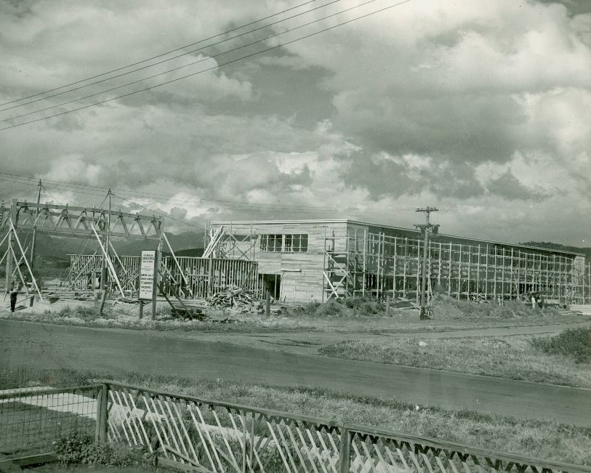
Mount Baker Secondary School – under construction 1950.
The above picture is looking kitty-corner across the dirt version of 14th Avenue and Baker Street. I almost imagine that might be the same power pole in front of the school today!
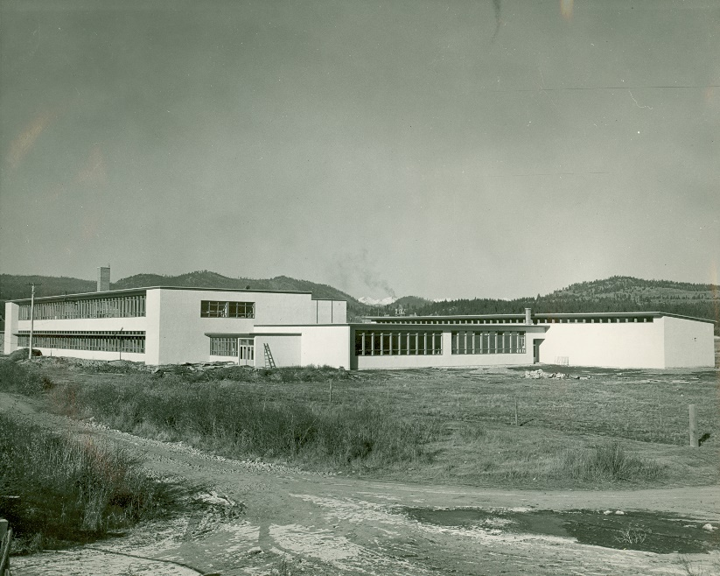
A finished and stuccoed school looking across Baker Street from what would now be the F.W. Green clinic.

Health and safety – Violence in the workplace
March 4 and March 11, 2021 Occupational Health and Safety Training was facilitated by Larry Dureski and Sarah Jones. The purpose of the meeting/training was to become familiar with the SD5 Policy 3.2 – Non-violence policy.
Occupational Health and Safety Regulations 4.27 definition: “Violence” means the attempted or actual exercise by a person, other than a worker, of any physical force so as to cause injury to a worker, and includes any threatening statement or behavior which gives a worker reasonable cause to believe that he or she is at risk of injury.
Abusive behavior including harassment and intimidation may cause harm to students or staff. Such behaviour will not be tolerated. All incidents of violence and/or threats of violence that involve staff members and students shall be reported and investigated. (SD5 Creating Safe Schools Non-Violence Policy Section 3.2)
Prevention Plans include: information on what is the risk of violence in the situation; what persons are the potential source of violence; who is likely to encounter the violent behaviour; how to recognize the violent behaviour; what procedures, policies, and work arrangements are in place to minimize or control the risk of violence; how to respond to a violent incident; how to get help; how to report, investigate, and document the violent incident.
Violent Prevention Plans are not Individual Education Plans (IEPs)
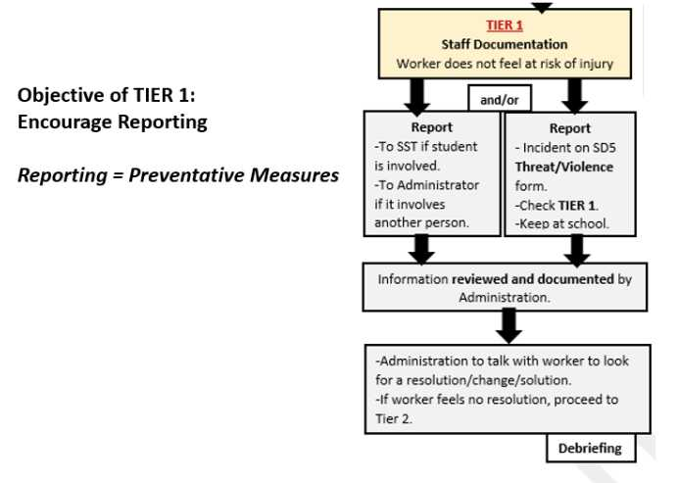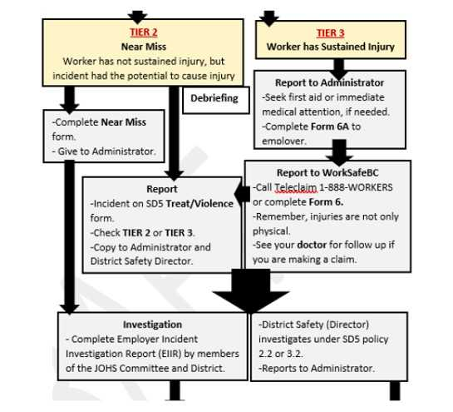
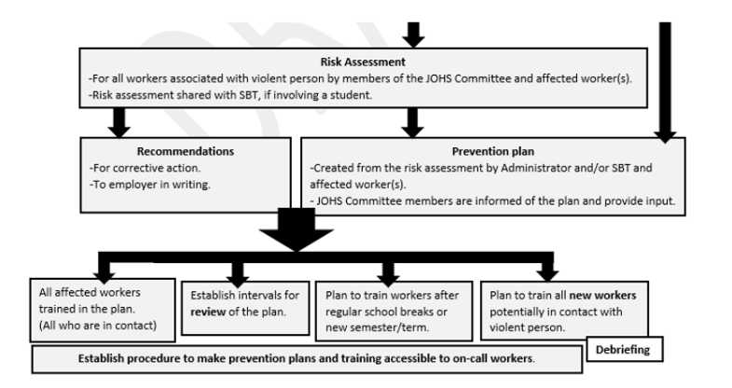

UPCOMING EVENTS
March 20-23, 2021 BCTF VIRTUAL AGM
March 22 – April 2, 2021 SPRING BREAK
April 2, 2021 Good Friday – No School
April 5, 2021 Easter Monday – No School
April 7, 2021 Executive Meeting – 4pm
April 14, 2021 Pro-D Executive Meeting – 4pm
April 15-16, 2021 East Kootenay Zone Meetings
April 26, 2021 RSA Day
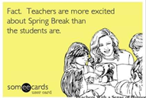
Be sure to check out the Cranbrook District Teachers’ Association webpage for easy access to your contract and up to date information.
www.cranbrookdistrictteachersassociation.com

